**Hussein Abdikarim CMPE 223 - SEC 05 99230997266 Assignment/ HW-2**

**PA REPORT- 1**

**Problem Statement and Code Design**

In this assignment, I created 2 classes Method and SortAlgorithmTester. In the Method class, there are two distinct methods mainly Method() and sortCheck(). As for the C class, there are 2 methods but the main method is main() where all the program relies on. The diagram below shows the methods used in this program and the arrows simply show the flow of the program.

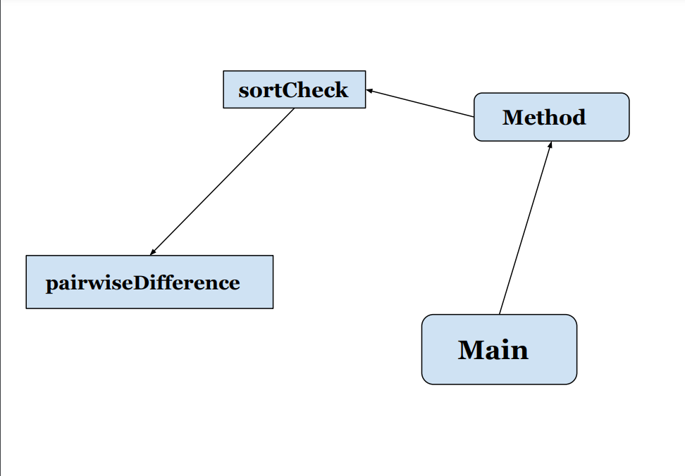

**Implementation, Functionality**

**How does it work?**

First of all, the program starts with main() in the SortAlgorithmTester class where it creates an int array and 2 string arrays. These arrays have input sizes, sort algorithms and array types respectively. It then generates a seed from the user to use it for generating a random array that takes various input sizes as its elements. From there another loop is created for the purpose of measuring time. In that loop, the method Method() is invoked and executes 3 times based on the output

To explain furthermore, the forementioned methods above will be defined as follows.

1. **Main():**it creats 2 string arrays and int array and checks for various diff outputs. Then creates another loop to measure the time of these algorithms**.**
2. **Method():** Takes 2 inputs from the previous method and invokes the sortCheck().
3. **sortCheck():** also takes the same inputs from method Method() and compares the string input with the known sort algorithms. Otherwise, it prints an invalid algorithm**.**
4. **pairwiseDifference():** it takes an Integer array as input and creates an int array that only takes 2 elements. That is the elements being compared and have the smallest absolute value. Finally, it prints the difference and the paired difference array.

* **Testing** 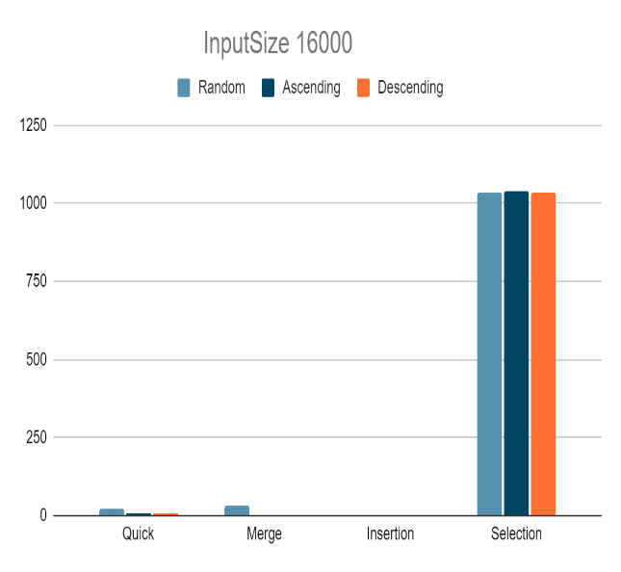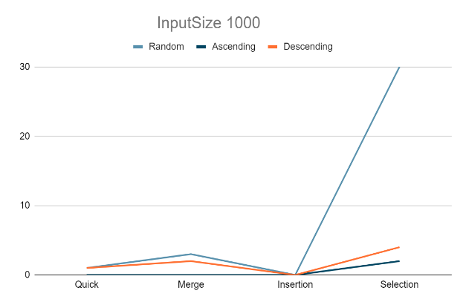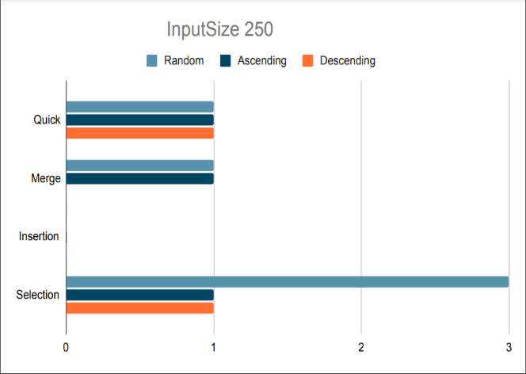

In this part, if you notice selection seems to be the slowest of them all. Although insertion sort should closer to this range, for some reason it gives 0 as average ‘time’ most of the time which I couldn’t wrap my head around. Another thing Is that out of the array types, the random array is the slowest mainly because the arrays are sorted unlike the random array.

**FINAL ASSESSMENTS**

I had challenges with this assignment but unlike the previous one, my confusion and misunderstandings were less compared to the 1st one. One area where I had a problem was in the lats part of the assignment where I have been trying to find the problem of my code. It did turn out to be a minor bug in the code. Overall, I’m very with the journey I went in this assignment and look forward to more challenges in the future.